**A Recommendation System to Select the Area to Rent a House**

**Introduction:**

Across the world, cities contain the major populations. People move across the cities/countries due to job change and personal reasons. Many times people not aware about the new cities infrastructures and best neighborhood to live that city. It will tough to select the location to live by meeting all the criteria’s. Many people come with different needs, like Family people may look for good schools nearby and Markets, Shops, Park etc. Bachelor’s looks mainly for restaurants, gym, pubs, theatres, shopping malls etc. People who have small kids and elderly parents may look for hospitals, yoga centers close by.

The idea is developing the recommendation system to suggest best neighborhood to live in the city based on the user’s requirements.

**Problem & Data Description**

For this particular project we will consider Bangalore, India as city and find the best neighborhood to live in. Bangalore city is selected due to following reasons. Bangalore is known as IT hub of India. So many people will come to Bangalore due to their job change from different cities or with in the city they may move to other location of the city for new job or better school or some of the amenities not available in their current location. So its difficult to understand the Neighborhood in the Bangalore due to different culture of people live there.

We use FOURSQUARE API to explore about the Bangalore city and make suggestion to the user. This approach can be used to any other city in the world as well. FOURSQUARE API provides helps to explore all the venues around the particular location. We use explore most of the neighborhoods in Bangalore using FOURSQUARE data and find the best place for the user.

The Bangalore neighborhood names collected and kept in the csv file. Using Geocoder library, the coordinates of the neighborhood is predicted and plotted in the Maps using Folium library (refer Figure 1).

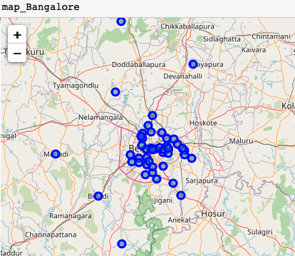

Figure1: Bangalore Maps with Neighborhoods

**Exploratory Analysis using FourSquare API:**

Using FourSquare API’s explore option, the neighborhoods are explored based on the different venues around the neighborhood location coordinates. For this explorations 1000 meter radius considered around the neighborhoods. For example, first try to explore the areas around Majestic Bangalore. FouSquare API provides the below Table1. The category of places around Majestic is shown in Table2. As per Table2, around Majestic more number of restaurants. So the common venue around Majestic is Indian restaurants…

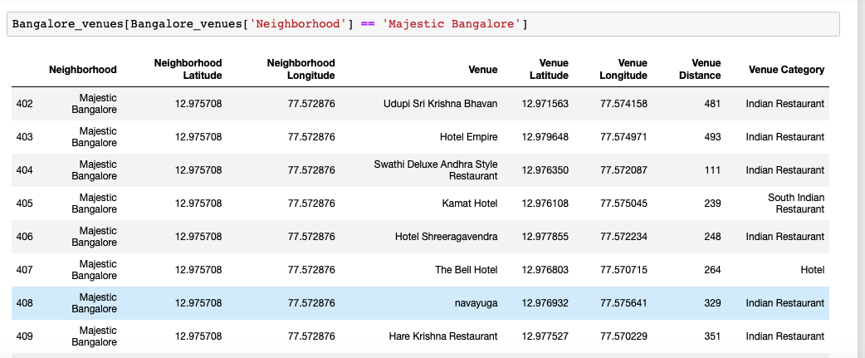

Table 1: Places around particular neighborhood (Majestic) in Bangalore

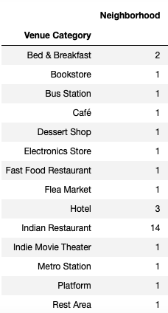

Table2: Venue Category around neighborhood, Bangalore

We can explore the all the neighborhoods in Bangalore using FourSquare API and group them together and find what’s the most common venue around the neighborhood and which neighborhood has most of the venues. The table3 shows Jayanagar, UB City, Brigade Road, Indiranagar neighborhoods has more number of venues.

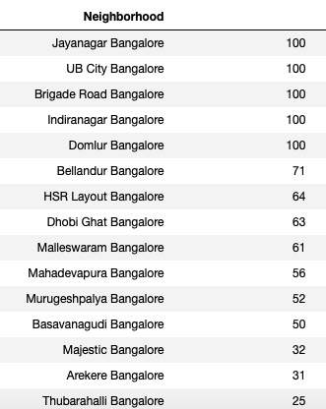

Table3: Total number of Venues in different neighborhood, Bangalore

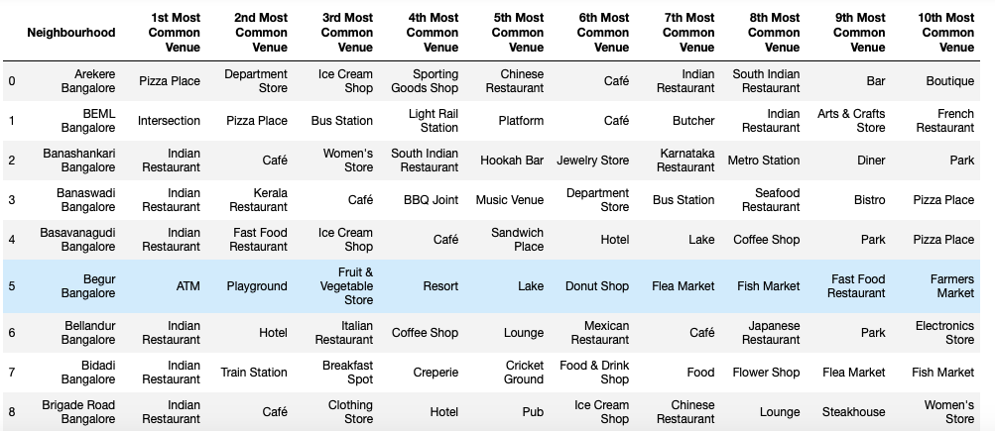

Table 4: Common Venues around the Neighborhood, Bangalore

**Using Machine Learning Cluster the Neighborhoods:**

Using K-means clustering algorithm cluster the neighborhoods into different buckets, which provides the ideas about similarity of the neighborhoods in Bangalore. K-means algorithm works based on the distance calculation. So all the categorical variables need to be converted into numbers using one hot encoding. The number of clusters defined as 6. Most of the neighborhoods falls under cluster 0 & 1. The outers of Bangalore into other clusters like 2, 3, 4, 5.

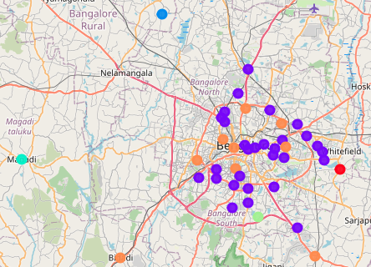

Since the clustering algorithm keeps most of the area in cluster 0 & 1 based on the common venues like Restaurants, Pizza, Coffee shops etc. But sometime the common man needs like Metro station, School, Park etc, Since FourSquare API provides limited amount of data for some of the neighborhoods. So in that we can use the FourSquare **Search** API to find the specific needs.

**Case Study1:**

Example the person wants recommendation of place between MurugeshPalaya and Tippachandra based on the Schools and Metro Stations nearby. Find the both locations coordinates using Geocoder library and the places are shown in Bangalore map below..

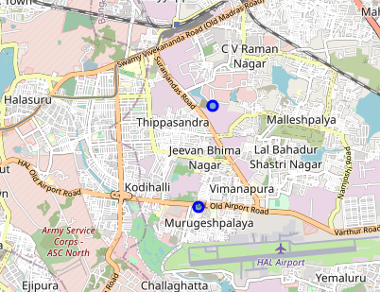

**Place1: MurugeshPalaya**

Schools near MurugeshPalaya

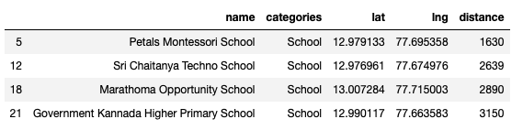

Metro Stations Near MurugeshPalaya

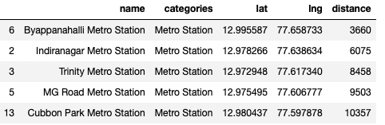

**Place2: Tippachandra**

Schools near Tippachandra

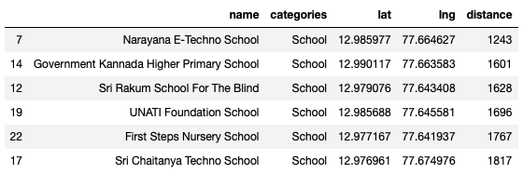

Metro Stations near MurugeshPalaya

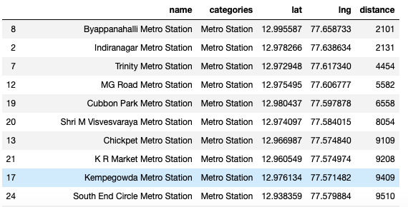

By comparing the two places, we commend **Tippachandra** is the best places to live compared to MurugeshPalaya, because the schools and metro stations are very close by and Tippachandra provides multiple options of schools and Metro stations as well.

**Conclusions:**

In this project using Foursquare API, explored the neighborhoods in Bangalore. Based on the common venues the neighborhoods are clustered using K-means machine learning algorithm. Since the common venues are not covers the common mans needs, one more case study done to compare the two venues based on the needs like school and Metro stations and recommend the best venue.